**Digital Signal Processing Lab**

# Lab EEL-325

Lab Journal: 8



Name: OMAR

Class: BCE-6

Enrollment No: 01-132182-024

**Lab # 8**

**Design of IIR filter using MATLAB command and MATLAB Tools.**

## Objective

This lab is aimed at.

* Designing IIR filter (low pass, high pass, band stop, band pass) using matlab command.
* Designing IIR filter (low pass, high pass, band stop, band pass) matlab tool (fdatool).

## Introduction

**Lowpass Filter:**

A low-pass filter (LPF) is a filter that passes signals with a frequency lower than a selected cutoff frequency and attenuates signals with frequencies higher than the cutoff frequency. The exact frequency response of the filter depends on the filter design. The filter is sometimes called a high-cut filter, or treble-cut filter in audio applications.

**Examples:**

* Low pass filters are used to filter noise from a circuit. 'Noise' is a high frequency signal. When passed through a low pass filter most of the noise is removed and a clear sound is produced.
* Using a low pass filter tends to retain the low frequency information within an image while reducing the high frequency information.

**Highpass Filter:**

A highpass filter is just a filter sometimes called a low-cut that attenuates low frequencies below a certain cutoff frequency and allows frequencies above to pass. There are many kinds of highpass filters that can appear at various stages in the signal path (e.g., the mic, the preamp, the equalizer/EQ plug-in, etc.) and they can have many different qualities.

**Examples:**

* The high-pass filters are often used in studio recording and sound reinforcement to attenuate extraneous low-frequency content like mechanical rumble or vocal plosives.
* Used in loudspeakers to attenuate bass signal that could interfere with, or damage, the speaker.

**Bandpass Filter:**

A band-pass filter or bandpass filter (BPF) is a device that passes frequencies within a certain range and rejects (attenuates) frequencies outside that range. In electronics and signal processing, a filter is usually a two-port circuit or device which removes frequency components of a signal which could be an alternating voltage or current. A band-pass filter allows through components in a specified band of frequencies, called its passband but blocks components with frequencies above or below this band.

**Examples:**

Bandpass filters are widely used in wireless transmitters and receivers. The main function of such a filter in a transmitter is to limit the bandwidth of the output signal to the band allocated for the transmission.

This prevents the transmitter from interfering with other stations.

**Bandstop Filter:**

Also known as band rejection filter is the reverse of band pass filter; it rejects the frequencies within the band and lets through frequencies outside it. The band stop filter circuit can be formed by combining a standard RC high-pass filter with an RC low-pass filter. In this, the RC low-pass filter will help to set the lower cut-off frequency, while the RC high-pass filter will help establish the higher cut-off frequency for the final filter.

**Examples:**

* Used in the electronics and communication circuit. They can be used to eliminate a band of unwanted frequencies while at the same time enabling other frequencies to pass with minimum loss.
* Used in radio communications to enable radio receivers to receive the desired signal while rejecting all other signals.

**Task 1:**

Designing IIR filter using matlab command and matlab tool.

* Low Pass filter
* High Pass filter

**Using Commands:**

**Low Pass filter:**

**CODE:**

n = 130;

[b,a]=butter(n,0.5,'low'); freqz(b,1); figure

[m,p] = freqz(b,a); plot(p,abs(m)) grid

**OUTPUT:**

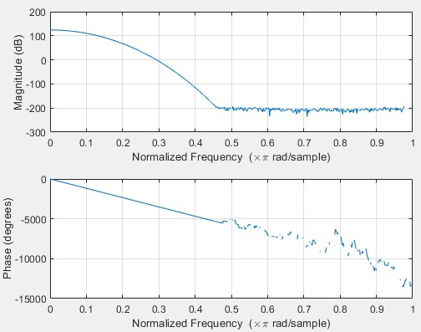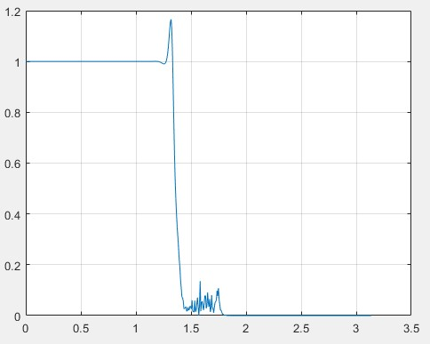

**High Pass filter:**

**CODE:**

n = 130;

[b,a]=butter(n,0.5,'high'); freqz(b,1); figure

[m,p] = freqz(b,a); plot(p,abs(m)) grid

**OUTPUT:**

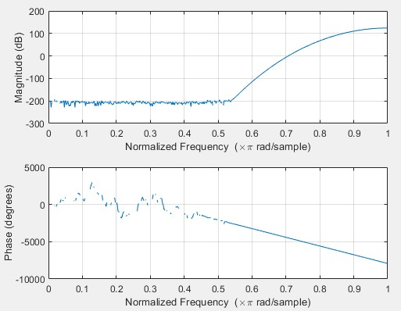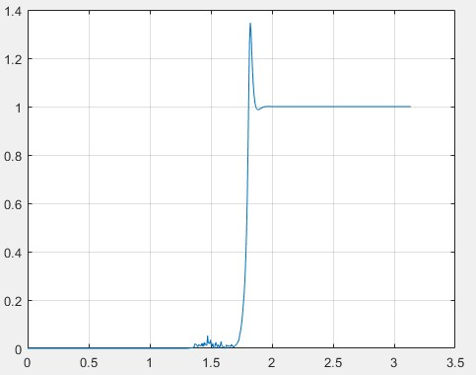

**Using Tool:**

**Low Pass filter:**

**OUTPUT:**

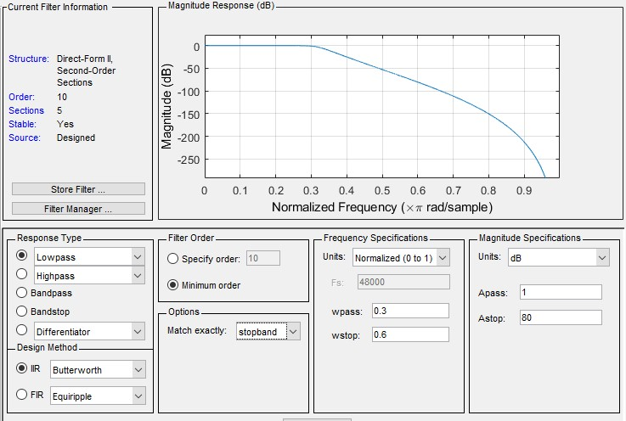

**High Pass filter:**

**OUTPUT:**

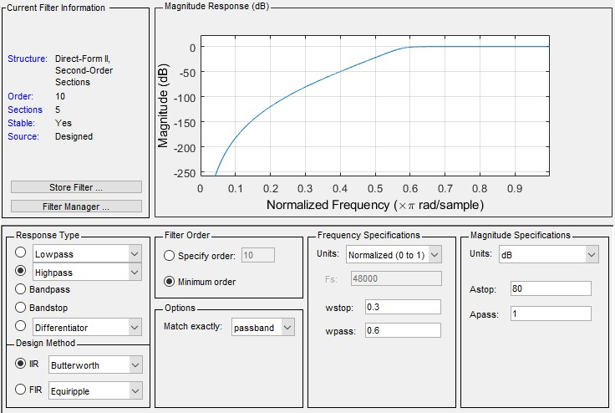

**Task2 :**

Designing IIR filter using matlab command and matlab tool.

• Bandpass IIR filter using Butterworth, elliptic, chebshev in coding. • Bandstop IIR filter using Butterworth, elliptic, chebshev in coding.

**Using Commands:**

**Bandpass IIR filter using Butterworth**

**CODE:**

n = 130; d = [0.5 , 0.7];

[b,a]=butter(n,d,'bandpass'); freqz(b,1); figure [m,p] = freqz(b,a); plot(p,abs(m)) grid

**OUTPUT:**

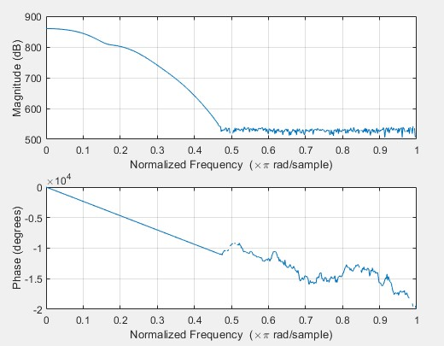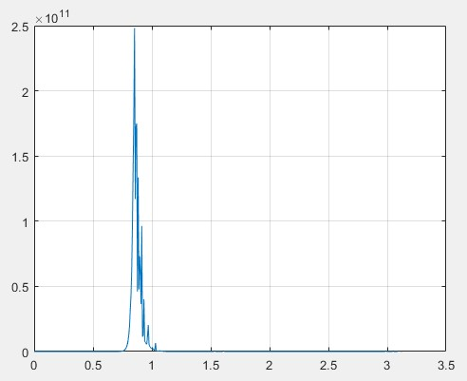

**Bandpass**

**using elliptic CODE:**

n = 6; Rp = 0.1;

Rs = 80;

Wn = [0.5 , 0.7];

[b,a]=ellip(n,Rp,Rs,Wn,'bandpass'); freqz(b,a); figure

[m,p] = freqz(b,a); plot(p,abs(m)) grid

**OUTPUT:**

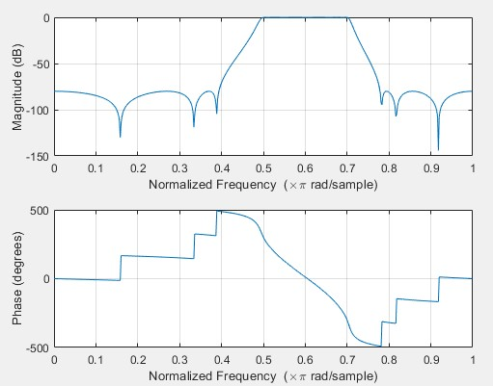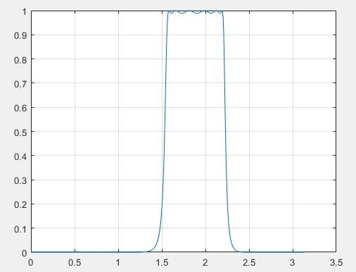

**Bandpass using chebshev**

**CODE:**

n = 6; Rp = 0.1;

%Rs = 80;

Wn = [0.5 , 0.7];

[b,a]=cheby1(n,Rp,Wn,'bandpass'); freqz(b,a); figure

[m,p] = freqz(b,a); plot(p,abs(m)) grid

**OUTPUT:**

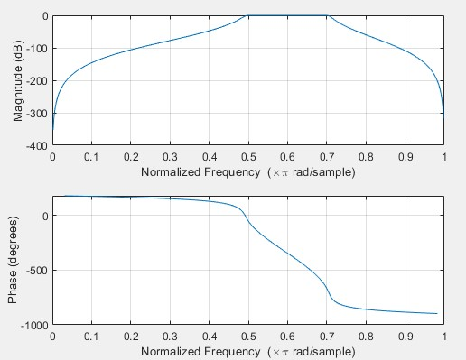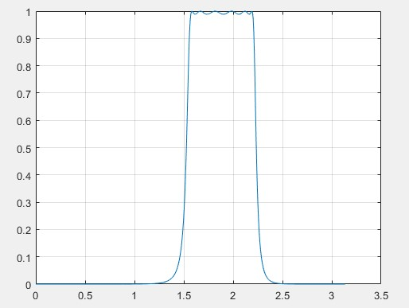

**using Butterworth**

**CODE:**

n = 130; d = [0.5 , 0.7]; [b,a]=butter(n,d,'stop'); freqz(b,1); figure

[m,p] = freqz(b,a); plot(p,abs(m)) grid

**OUTPUT:**

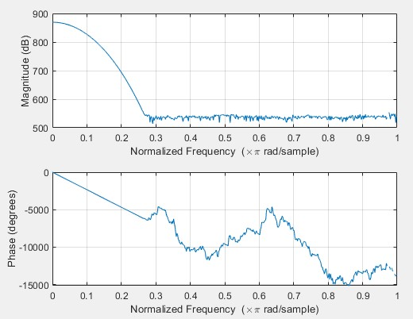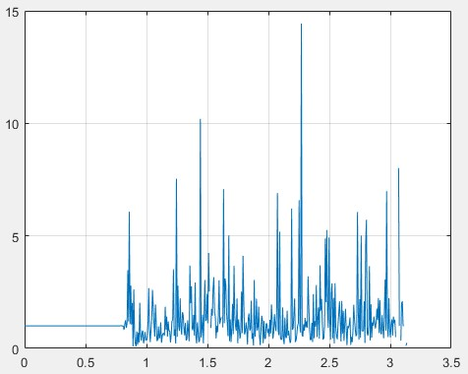

**using elliptic CODE:**

n = 6; Rp = 0.1;

Rs = 80;

Wn = [0.5 , 0.7];

[b,a]=ellip(n,Rp,Rs,Wn,'stop'); freqz(b,a); figure

[m,p] = freqz(b,a); plot(p,abs(m)) grid

**OUTPUT:**

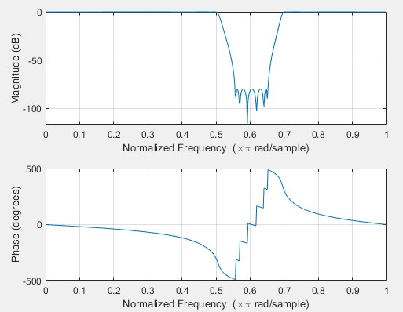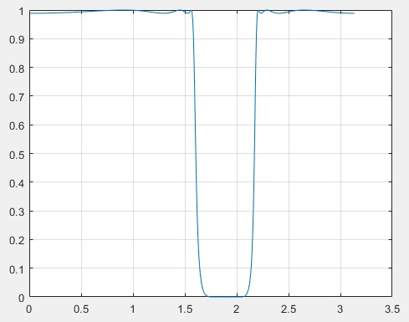

**using chebshev**

**CODE:**

n = 6; Rp = 0.1;

%Rs = 80;

Wn = [0.5 , 0.7]; [b,a]=cheby1(n,Rp,Wn,'stop'); freqz(b,a); figure

[m,p] = freqz(b,a); plot(p,abs(m)) grid

**OUTPUT:**

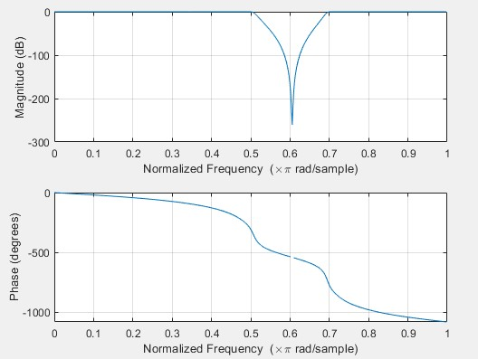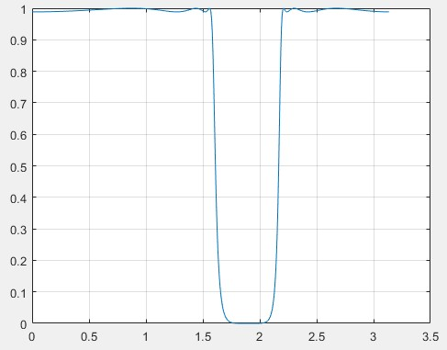

**Using Tool:**

**Bandpass IIR filter using Butterworth OUTPUT:**

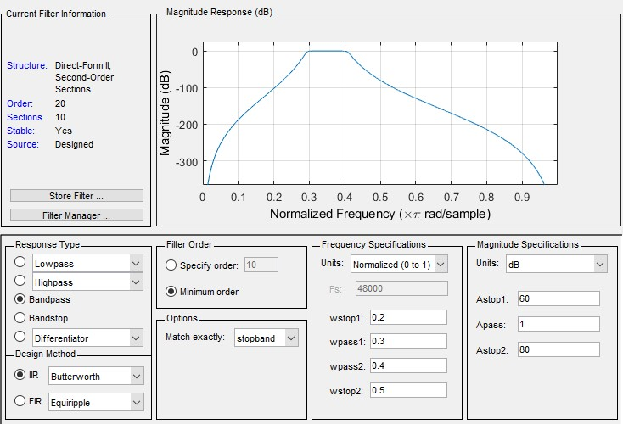

**Bandpass IIR filter using elliptic**

**OUTPUT:**

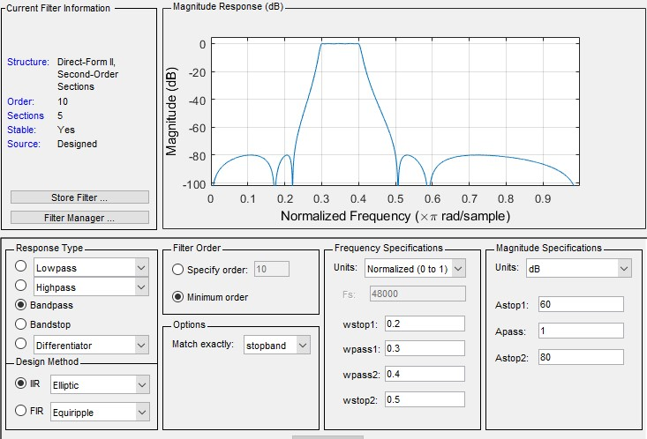

**Bandpass IIR filter**

**using chebshev OUTPUT:**

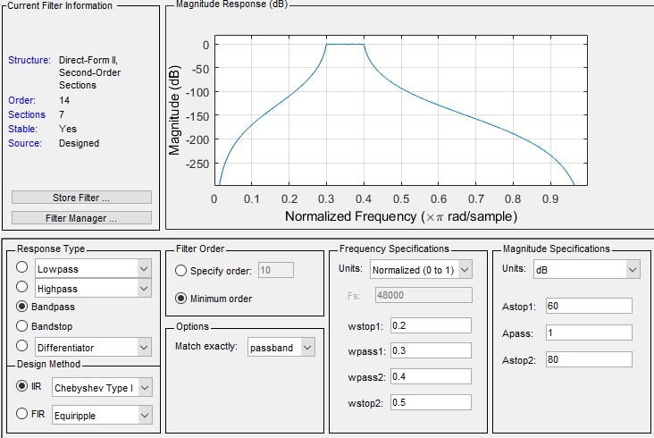

**Bandstop IIR filter**

**using Butterworth OUTPUT:**

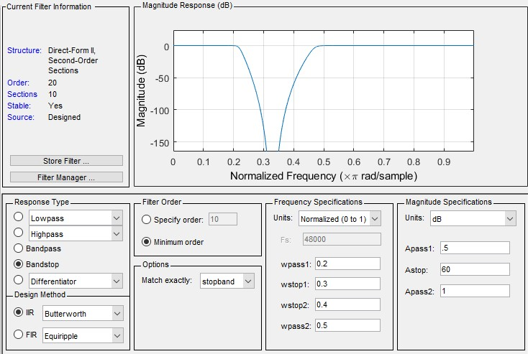

**Bandstop IIR filter using elliptic**

**OUTPUT:**

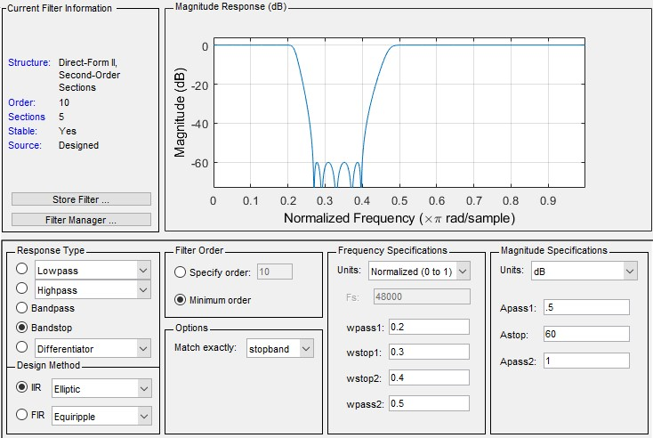

**Bandstop IIR filter**

**using chebshev OUTPUT:**

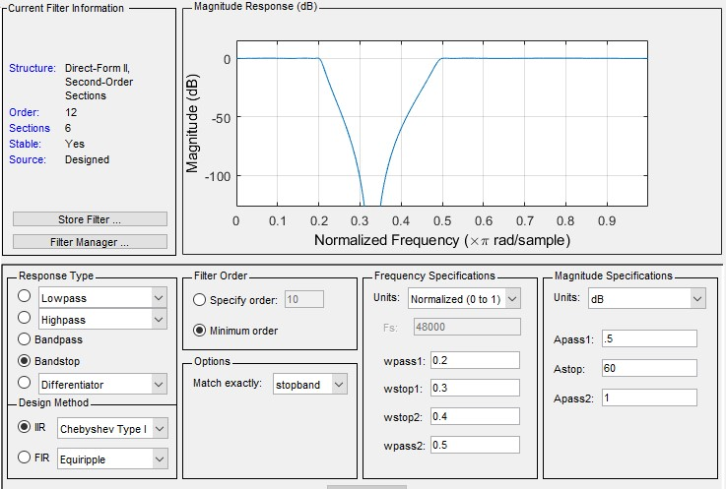

**Conclusion: -**

In this lab we learned about Design of IIR filter using MATLAB command and MATLAB Tools.